**Lab: Simple Sweats’ Information System**

Course Name: ANAP1525

Section: E01

Team 4: Da Hai (David) Wen

Likhit Budwal

Prince Selhi

Na Wang

Nan Wang

Aug 8th, 2017

Contents

Introduction and purpose of the report 2

Introduction 2

Purpose 2

Stakeholder Analysis 3

Identify stakeholders and analyze their needs 3

Discussion of the various types of information systems in use 4

Transaction Processing Systems (TPS) 4

Management Information System (MIS) 5

Paperwork system 6

Risk Analysis 7

Risks 7

List the risk management categories: 8

Summary and Recommendations 8

Summary 8

Recommendations 9

Diagrams and models 11

Context level DFD model 11

System level DFD model 11

Physical Data base model (please zoom in for clearer view) 14

Interface design 15

Screen one 15

Screen two 17

Screen 3 18

Report design 19

Report one: 19

Report two: 20

Report three: 21

# Introduction and purpose of the report

## 

## Introduction

The Simple Sweats Inc. Company located in Norman. They provide many kinds of sweat-clothes to costumers. The sale system is divided to three main parts which are sales-order, distribution-billing and purchasing. However, there are some problems about the current system which caused the drop of profits. Therefore, the current system needs to be tested, upgraded and modified.

This report will analyze the current system and provide recommendations for information infrastructure problems by following steps:

1. This report will analyze stakeholders. Stakeholders can influence the organization, and their opinions should be considered when the company makes a decision.
2. Then, this report will discuss and analyze a variety of information systems in use and figure out which parts of systems have disadvantages and problems, and which parts are not convenient for costumers.
3. Thirdly, this report is going to do risk analysis of the systems.
4. Finally, a summary and recommendations will be provided for the company, in order to enhance the current system.

## Purpose

The purpose of this report is to help the company identity the problems within the current information system, and reduce the risks for the company. Therefore, there are some problems of the system should be considered.

1. The current system is inefficient. Through modifying, the company will get a more effective system which could reduce the re-working steps and make the processes more efficient.
2. The company do not have an integrated database, so it is difficult to get orders information between different processes. However, if the integrated database is created and used, these information can be retrieved quickly and easily.
3. Interacting with costumer is the key point for sales. However, there is no efficient systems which can make company contact with costumer conveniently. Therefore, the company needs a system which can provide better customer service and satisfaction to increase their sales.

# Stakeholder Analysis

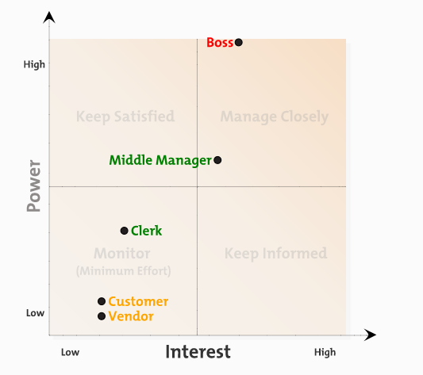

## Identify stakeholders and analyze their needs

|  |  |  |
| --- | --- | --- |
| **Stakeholder** | **Needs/Interests** | **Attitude** |
| Simple Sweats(boss) | 1. More efficient system 2. Integrated database 3. Increase sales | Request project delivery |
| Middle Manager | 1. More efficient system 2. Integrated database 3. Increase sales | Sell its products. |
| Clerk | 1. New system easy to learn 2. New system easy to use | Don’t care |
| Vendor | 1. New system easy to use 2. New system increase sales. | Intend to sell more products to increase profit. |
| Customer | 1. Faster delivery 2. Credit check need to be changed 3. Return/Cancel Order | Don’t care |

# Discussion of the various types of information systems in use

Depending on the analysis of the Simple Sweats Process, we could figure out there are three types of information systems in use currently:

1. Transaction Processing System (TPS)
2. Management Information System (MIS)
3. Paperwork System

Based on these three systems, the business of Simple Sweats was considerable growing in the first two years; however, these systems cannot provide effective support when the company becomes larger. Therefore, the company needs to figure out how to enhance the systems, and at the same time to reduce the re-work steps.

## Transaction Processing Systems (TPS)

For example, when the company received the orders from the customers, the orders (data) will be transferred step by step in processing. To improve the current DPS, these following key-points should be considered:

**Re-working problems**

1. Order information was already entered on the form, but the clerk still needs to enter these information again in Microsoft Word.
2. When the order is calculated, the clerks should check the amount which is higher or lower than $500; if more than $500, they need to check if the customer has been approved or not.

**Different types of applications in use**

There are three kinds of applications in use to store data

1. Microsoft Word
2. Microsoft Excel spreadsheet
3. Microsoft Access

When different applications are used to store data, they cannot communicate with each other. When people need to transfer data from one application to another, it is easy to make mistakes because data may be stored in different types and format in different applications, and sometimes it’s easy to miss one letter or copy one more blank space in the data.

## Management Information System (MIS)[1]

Although there are some procedures to help clerks to manage order information, the company does not have an effective management information system in use, because there is no procedure to report management information back to the company, and no procedure to gather data from suppliers and customers to help with making future plans or accurate decisions in current situation. These following key-points should be considered:

**Unnecessary Steps**

In processing of an order it may be transferred into different folders too many times, which includes:

1. Template Folder (First folder to store orders)
2. INBOX Folder
3. Rejected Folder
4. Approved Folder
5. Back Order Folder
6. Shipped Folder
7. Completed Folder
8. Purchase Folder

Although it seems that orders in processing are protected and transferred step by step. In the real situation, more steps means more mistakes. Moving orders from one folder to another folder are all manually done by clerks. The manual procedures can lead to mistakes easily.

**Lack of inventory control**

There is no procedure to help clerks to control the inventory level. The only way is by checking the inventory level manually when it is necessary to find out such information, this is because:

1. No procedure to notify the inventory level
2. No suitable tracking of shipment system

In the current business, sometimes express delivery is even more important than the products. Automatically notifying clerks the inventory level when it is in low level.

**Orders exceed $500 & customer’s credit verification**

The company does not want to take risks when the order value is more than $500, therefore the current system set it as the limit line. If the orders exceed $500, then the clerks need to check the customer’s credit and status. To enhance this method, we need to do the risk analysis first, then to find a suitable way or solution for managing customer credit issues.

**Lack of interacting with customers**

There is no effective way to communicate with customers by using the current system. The company needs to gather data from customers to

1. Understand what they want now
2. Understand what they need in the future
3. Make connections with customers to improve the relationship which will benefit the business
4. Based on these data, the company could make better decisions for the future

## Paperwork system

When clerks are doing their jobs, they are not only focusing on computer works, but also paying attention to paperwork. The current system used too much paper during in processes. To improve this, the following key points should be considered:

**Too much paper in the current system**

The clerks need to deal with too much paper during the process

1. Receive Original Orders
2. Save the original orders to the binder
3. Print out two copies when orders approved
4. The print out order will attach to available product then send to press name/logo
5. Two order sheets will be invoices
6. One packed with orders
7. Another sent to the order clerk
8. The purchasing clerks need to recorder the quotes in a notebook
9. Print out two copies purchase orders
10. One is sent to the vendor
11. Another is stored in a binder to verify incoming shipments.
12. If the shipments are correct, the clerk who receives the purchase order needs to write his/her initials on it.

These steps involves too much paperwork, and at the same time the clerks also need to do the work using the Data Processing System and the Management Information System. That will be a huge chance to make mistakes, especially when the company grows up and takes more and more orders.

**The paper system is only used for reference and storage**

The paper system does not help with the data flow system, the only purpose of this system is for reference and storage, which includes:

1. Folder for Sales Order
2. 3-Rings-Binder for original orders
3. Binder for Purchase Notice
4. Notebook for prospective purchase orders
5. Binder for purchase order

# Risk Analysis

## Risks

These following threats depend on the Simple Sweats Program, we will figure out these risks in current use:

**Customer Credit Verification**

Although the company does not want to take risks when the order amounts are more than $500, by conducting credit check, it may have risks of losing reputation and potential customers.

**Redundant effort**

Orders are written in forms, and they are also needed to enter in Microsoft Word documents.

**Manual Work**

Many manual procedures involved in the processing, such as moving orders from one folder to another many times. It is a risk of occurring errors and corruption of folders which could lose order information.

**Tracking System**

The company does not have an effective way to track products, which means tracking system is lack of ability to notify the clerks the quantity of products and the shipment time.

**Profits**

The profits of the company is dwindling. This issue will stop the company developing.

**Procedure**

No process deals with the order cancellation, payments and shipment delay.

It may result in losing customers, profits and creating chaos in inventory management.

## List the risk management categories:

Acceptable, Avoidance, Reduce probability, and Reduce Impact



# Summary and Recommendations

## Summary

**Subject matter**

This report provides an analysis and evaluation of the current information system for Simple Sweats Inc. Company.

**Methods of analysis**

* Context level DFD model
* System level DFD model
* Narrative description of processes modelled
* Stakeholder analysis
* Discussion of the various types of information system in use
* Risk analysis

**Findings**

Results of analysis show the company’s information system cannot effectively support the company’s profitability to continue to expand its business. The following is a breakdown of the most critical problems (details in the system discussion section):

* Redundant works, such as writing on forms then entering the same thing in the computer
* The system involved too much paperwork
* The multiple manual procedures can cause human errors easily
* Lack of integration in process and data. When clerks deal with different typies of data in different applications, it is easy to make mistakes
* Lack of inventory control. No procedures to effectively determine when to replenish inventory
* The verifycation of customer status is ineffective
* Lack of interaction with customers.

**Conclusions**

The report finds the Simple Sweats’ information system has various problems which could prevent the company’s growing demand. The weakness areas require further investigations and remedial actions by management.

## Recommendations

* Reduce redundant procedures, such as avoid entering the same form twice
* Eliminate paperwork system, and store data digitally which could benefit in cutting costs
* Reduce manual procedures to limit human errors
* Implement inventory control in the system and dealing with shipments. For example, in the shipping process, update the quantity on hand of the inventory
* Create an integrated database that ties all the key elements of sales, production, distribution, billing, and administration together
* Enhance the customer status approval procedures
* Adopt the online shopping website to increase sales
* Introduce processes deal with the order cancellation, payments and shipment delay

# Diagrams and models

# Context level DFD model

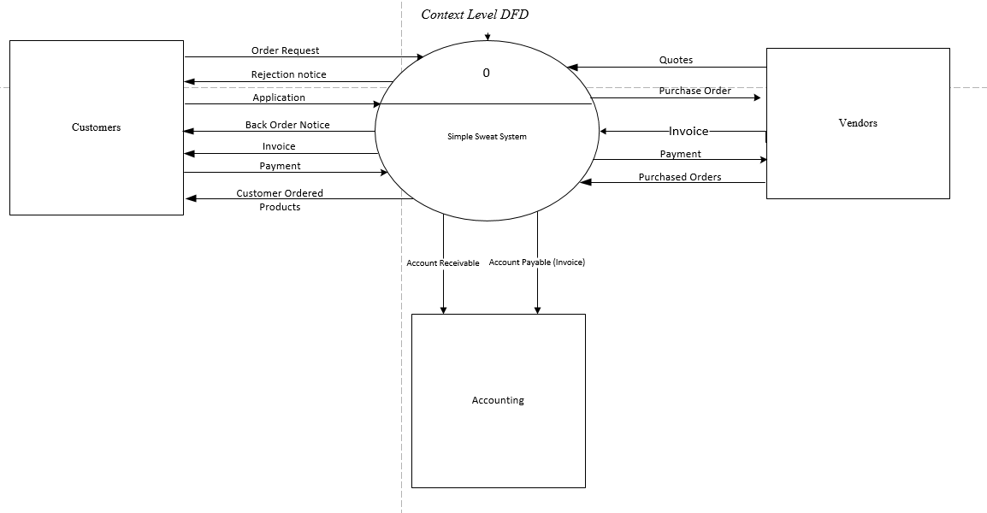

# System level DFD model





# 

# Physical Data base model (please zoom in for clearer view)



# Interface design

The goal is to make the interface easy to use, minimize user’s effort while pleasing to the eye.

The interface layout contains a series of areas on screen that are used consistently for different purposes. User is aware of where he/she is in the system and what information is being displayed. Interfaces are functional and inviting to the user with use of white space, colors and fonts. With consistency in interface design, user experience is kept being easy-to-use and user effort is minimized.

Screen one**:** Customer Order screen.

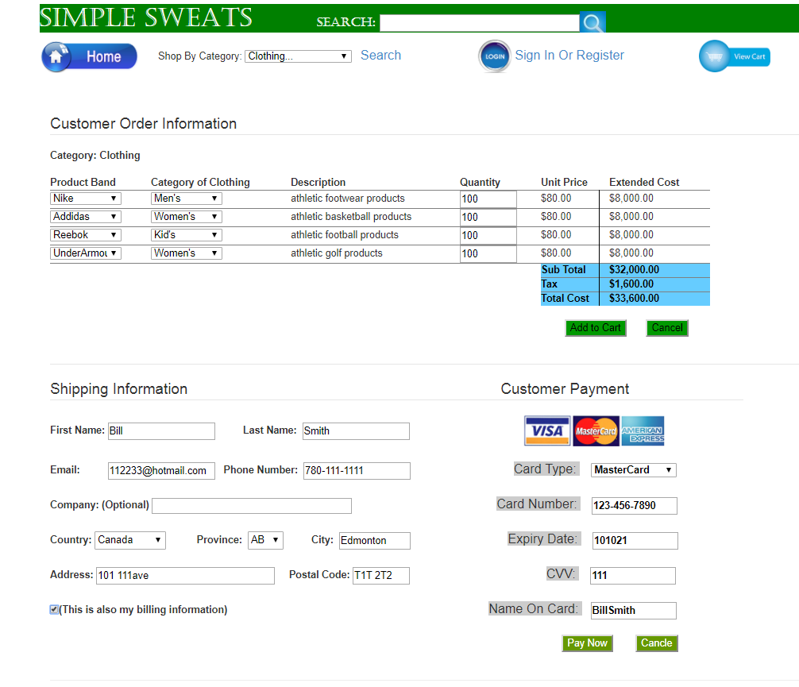

**Navigation mechanism**

At the green title bar on top of the screen, user (client) can search product via the search bar. Below the Simple Sweats is a home button which takes user to the home page. Beside the home button, user can pick a category using the drop-down list box. After choosing the category, the client need to click on the blue search text to display the category below (e.g. Clothing). Whether the user is the browsing shopper or the hurry-up shopper, one can click on view cart to view items in shopping cart.

The customer order information section displays the user selected category, here user can input selections. Upon completing input, the user can click add to cart to add order to the shopping cart or cancel the order.

At the Customer Payment section, the user can click cancel the cancel the order, or choose to pay now to tell the system that the order input is complete, and the system will change the purchase order status from open to close.

**Input mechanism**

The system captures information through different areas.

At the top of the screen, the system uses text box and drop-down list box to capture the product category from the user.

At the customer order information section, the system uses drop-down lists to captures the product brand and category of clothing. Then uses text box to acquire the quantity from the user.

At the shipping information section, the system captures the customer information using the familiar text boxes and drop-down lists.

At the customer payment section, the system captures the user’s payment information with, again, the text boxes and drop-down lists.

**Output mechanism**

The system displays the clothing category information to the user based on user’s choice of the clothing category. Depending on the user’s selection of product brand and category of clothing, the system displays the description, unit price. Upon receiving the quantity, the system then displays the extended cost, subtotal, tax and total cost to the user.

At the shipping information section, the system acquires the customer information and stores it in its database.

At the customer payment section, the system gathers information to output for the account receivable and sending it to Simple Sweat’s accounting department.

Screen two: Purchase Order Screen.

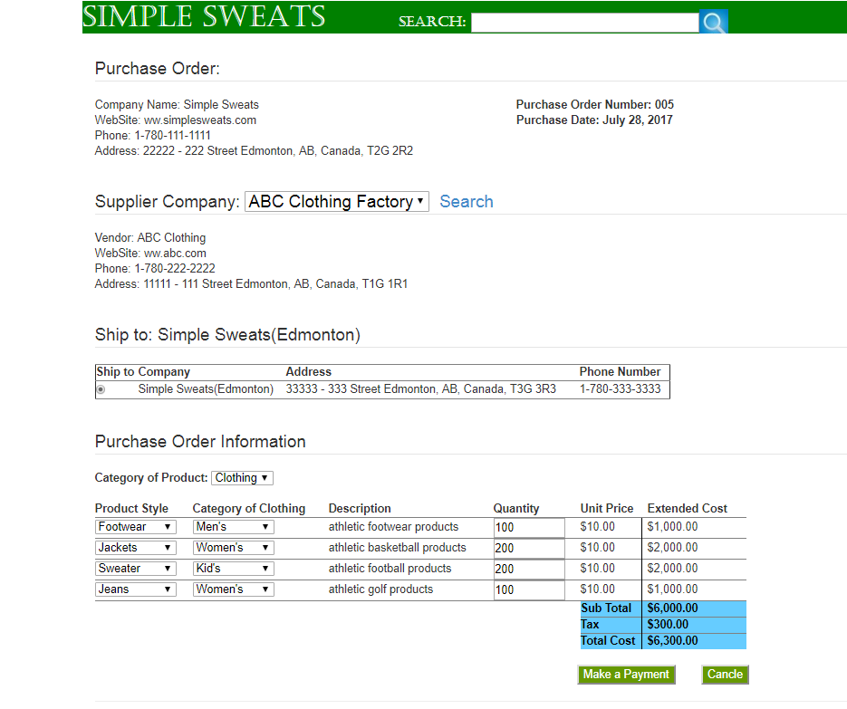

**Navigation mechanism**

At the green title bar on top of the screen, user can search product via the search bar it’s easy to user to find a particular item which they want.

In main page there is a switch button in which user have a choice of selection between different supplier and beside there is a search button also if user want to search a particular supplier. When user select a supplier is shows the details of the supplier below the switch button.

After that in main section there is a radio button defaulting the Simple Sweats’ address. This section will help with the company’s future expansion to other locations.

The Purchase Order Information section will use a drop box to let user to select the category of product, then displays the relative fields of input mechanisms.

At the end, the user can choose to cancel order or make a payment to complete the order.

**Input Mechanism**

At the middle of the main section there is a switch button of category of product in which user click it shows list of different type of product category.

The system uses drop-down lists to capture the product style and category of clothing. It also uses text box to acquire item quantity.

**Output Mechanism**

Header of the Page section outputs Simple Sweats’ company information: address, website, phone number and Purchase number and date of purchase.

The system displays the supplier information based on user’s selection.

The system displays the clothing category information to the user based on user’s choice of the clothing category.

Third column in the Purchase Order Information section is description of the product based on user’s input. The system displays the unit price, upon getting the quantity, the system then shows extended cost, subtotal, tax and total cost.

Screen 3**:** Invoice Screen

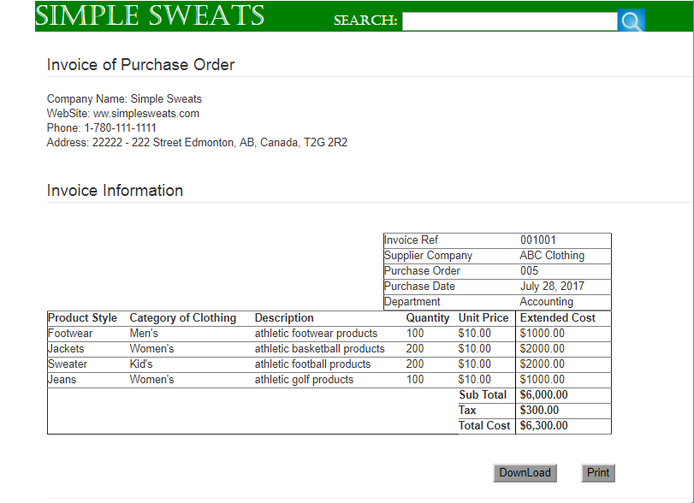

**The Navigation mechanism**

At the green title bar on top of the screen, user (client) can search product via the search bar. Below invoice of the purchase order is given along with the company information. Invoice contain reference number, purchase order number, Supplier Company and purchasing date. Apart from this it also contain products’ information like product style, category of clothing, description, quantity, unit price, and extended cost. Below the invoice there is download and print button which gives the user option to download the invoice or either print it.

**The input mechanism**

At the top of the screen, the system uses text box to capture the product category from the user. The section below invoice where download and print button, give command to the system to either download or print the invoice.

**The output mechanism**

The system here displays invoice of purchase order. It includes every information like reference number, purchase order number, Supplier Company and purchasing date. Apart from this it also contains products’ information like product style, category of clothing, description, quantity, unit price, and extended cost.

# Report design

Report one: Monthly Customer Order Report.

Type: Internal Output (Detailed Report)

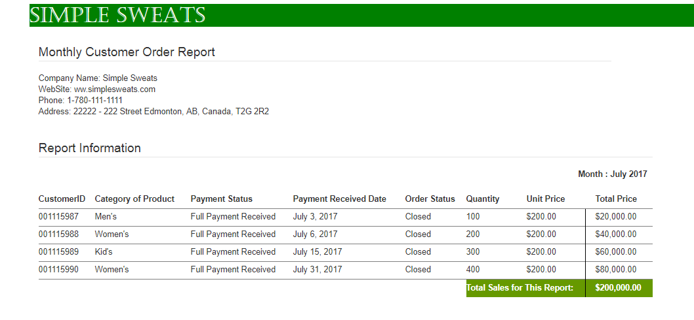

**Title:** Simple Sweats’ Monthly Customer Order Report

**Section headings:**

Monthly Customer Order Report section contains company information.

Report Information contains the monthly customer order report.

Month: Displays the month and the year of the report.

Total Sales for this Report: Displays the monthly total sale in CAD.

**Column headings:**

Customer ID: contains the customer’s ID. Each number represents a customer’s order

Category of Product: contains the product’s category. This information help the company to plan the marketing direction.

Payment Status: Shows whether payment has been received.

Payment Received Date: Display the date when payment was received.

Order Status: Displays the ordering status, open or close.

Quantity: Displays the item quantity.

Unit Price: Displays the unit price in CAD.

Total Price: Displays the total price in CAD. Each represent the total price for an order.

**Narrative:**

This report is an internal report generated at the end of each month for Simple Sweats’ sales and order department. The report displays all the customer orders of the month. The section headings and column headings contains Company and ordering information which have been illustrated above.

The customer with ID 001115987 ordered Men’s product and made full payment on July 3, 2017. The order status is closed. The order quantity was 100 with $200.00 per unit. The total price of this order was $20,000.00.

The customer with ID 001115988 ordered Women’s product and made full payment on July 6, 2017. The order status is closed. The order quantity was 200 with $200.00 per unit. The total price of this order was $40,000.00.

The customer with ID 001115989 ordered Kid’s product and made full payment on July 15, 2017. The order status is closed. The order quantity was 300 with $200.00 per unit. The total price of this order was $60,000.00.

The customer with ID 001115990 ordered Women’s product and made full payment on July 31, 2017. The order status is closed. The order quantity was 400 with $200.00 per unit. The total price of this order was $80,000.00.

Report two: Internal Monthly Raw & Pressed Inventory Report

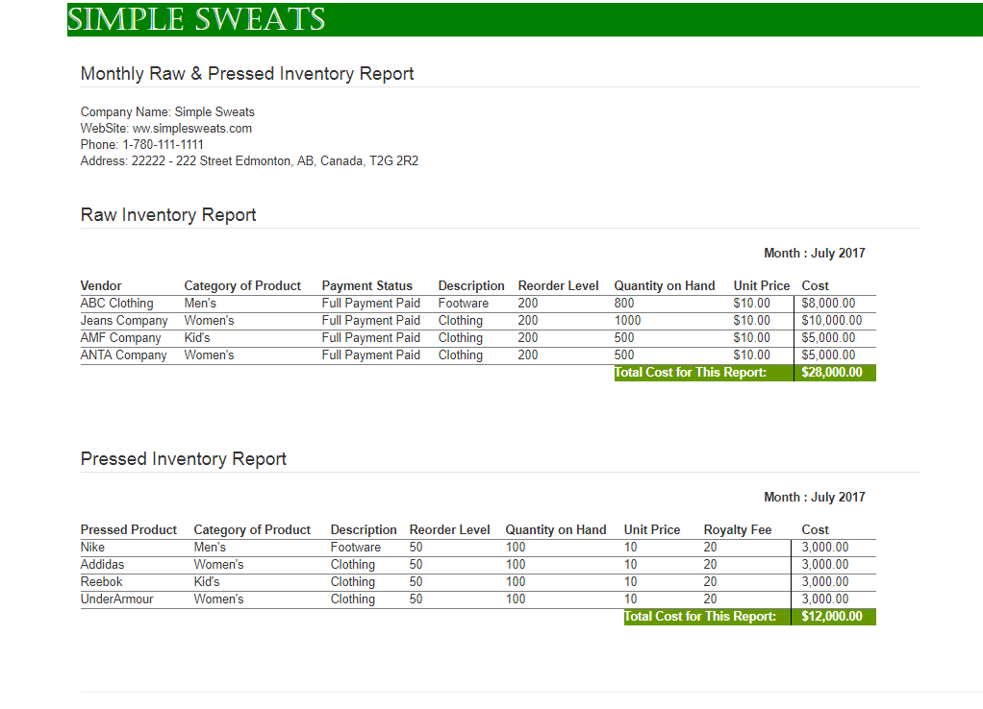

**Monthly Raw Inventory Report** – A raw inventory of month July 2017 is made. The total cost of July monthly report is $28,000.00

Women’s category products is received from Jeans Company and ANTA Company. It already fully paid and there is reorder level was 200 and quantity of hand is 1000 from jeans company and 500 from ANTA company and unit cost of per product is $10.00 and total cost of products of jeans company is $10,000.00 and $5,000.00 of ANTA company and kid’s products is receive from AMF company it also full paid and it reorder level is 200 and quantity is 500 and unit price $10.00 total cost of the product is $5000.00 and 800 quantity on hand is received from ABC clothing and it already full paid and it is Men’s Footwear and unit cost is $10.00 and total cost of products is $8000.00

**Pressed Inventory Report** – A Pressed inventory report of month July is made. The total cost of the report is $12,000.00

Pressed product of Nike Men’s Footwear has 50 reorder level and 100 quantities on hand and per cost of these product is $10 and royalty fee on that products is $20 and total cost of these products is $3,000.00. Women’s clothing of brand Adidas and Under Amour has reorder level 50 and quantity on hand 100 and unit cost is $10 of these products and royalty fee is $20 and total cost is 3,000.00 of women’s wear and 100 quantities on hand kid’s wear of Reebok Pressed Product has reorder level 50 and unit cost is 50 and royalty fee is 20 of these products and total cost of these is 3,000.00

Report three: Internal Monthly Purchase Order Report

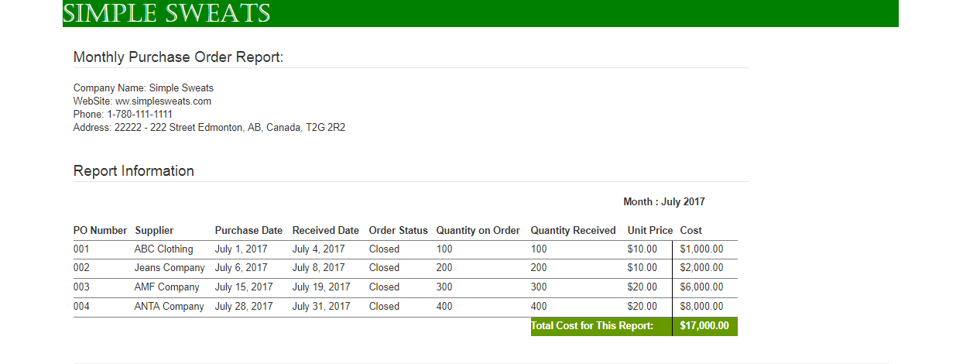

Four purchases were made from different suppliers in July 2017. The total cost is $17,000.

The supplier with purchase order number 001 and 002 are ABC clothing and Jeans Company respectively. The purchase from ABC clothing was done on July 1, 2017 and product was received on July 6, 2017. The quantity on order and the quantity received was same that is 100 pieces with $10 of unit price, so their total was $1000. Jeans Company’s order was given on July 6, 2017 and received on July 8, 2017 and amount of quantity received was same of provided on purchase order which is 200 wit unit price of $10 with a bill of$2000.

AMF Company with purchase order number 003 delivered 300 pieces on July 19, 2017 and their order was generated on July 15, 2017. The price of each pieces is $20 and their total was $6000. The last order of the month was made to ANTA Company on July 28, 2017 which included 400 quantities on order. The ordered products were received on July 31, 2017. Unit price of these product is $20 with and total was $8000.

All four orders are closed and payment is paid.

1. https://en.wikipedia.org/wiki/Management_information_system